

POWER BI|EXCEL|MYSQL

# Capstone Project – Hotel Booking Analysis

PUBLICATION

Analyzing hotel bookings is a complete study of data related to room reservations. It aims to get useful knowledge for making big decisions and improving how things in hotels.

HOTEL BOOKING ANALYSIS



This involves analyzing guest information related to hotel bookings. It could include demographics, preferences, booking patterns, and any other relevant data to understand and enhance the guest

HOTEL BOOKING GUEST INFO ANALYSIS

Examining data associated with meal and accommodation bookings. This analysis may focus on the correlation between types of meals chosen and the duration of the stay, providing insights into guest behavior and preferences.

MEAL AND STAY HOTEL BOOKING ANALYSIS

Evaluating the sources through which guests find and book hotel rooms. This analysis can help identify effective marketing channels and understand how historical data contributes to booking trends.

Source and History Hotel Booking Analysis

HOTEL ROOM ANALYSIS

Examining the characteristics and performance of different hotel rooms. This analysis may include

occupancy rates, pricing strategies, and guest satisfaction metrics for various room types.

Studying the reservation process, including booking patterns, cancellation rates, and factors influencing reservations. This analysis aims to optimize the reservation system and improve overall efficiency.

HOTEL RESERVATION ANALYSIS

Addressing questions related to Exploratory Data Analysis (EDA). This involves using statistical and visualization techniques to explore data, identify patterns, and derive meaningful insights.

EDA QUESTION SOLUTION

Creating a visual representation of key performance indicators and metrics related to hotel bookings. An Excel dashboard provides a user-friendly interface for monitoring and analyzing data trends.

EXCEL DASHBOARD

Leveraging SQL (Structured Query Language) to analyze and query the database associated with hotel bookings. This could involve extracting specific information, aggregating data, and gaining insights through SQL queries.

SQL ANALYSIS



Objective: The objective of this project is to create a comprehensive Power BI dashboard utilizing the Sample Publication Database. The dashboard aims to provide valuable insights into the publishing company's book sales performance, author royalties, and store distribution, enabling data-driven decision-making and strategic planning.



Analysis Scope: The analysis will focus on various aspects of the publication process, including book sales, author contributions, store performance, and the impact of discounts. It will encompass historical sales data, author royalties based on royalty schedules, and distribution data from multiple bookstores.

Goal: The primary goal of this Power BI dashboard is to offer a holistic view of the publishing company's operations. It will provide actionable insights to optimize book sales, enhance author collaboration, improve store distribution strategies, and identify opportunities for growth and efficiency.

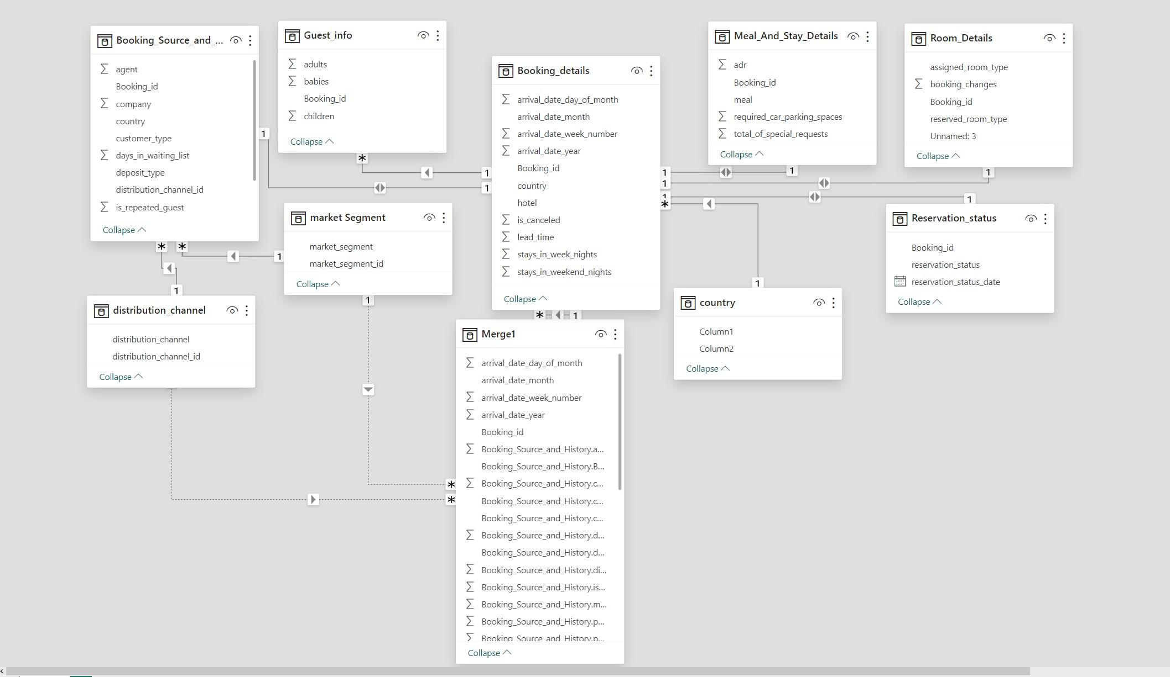ER Diagram

FINAL MERGER TABLE

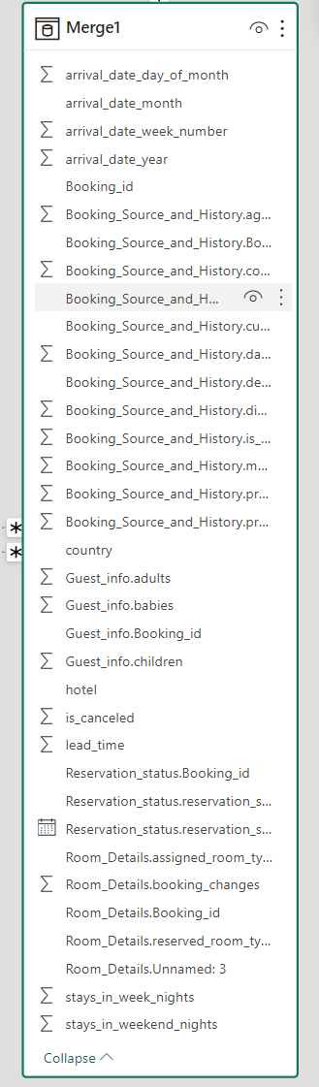



# POWER BI – Hotel Booking Analysis

A

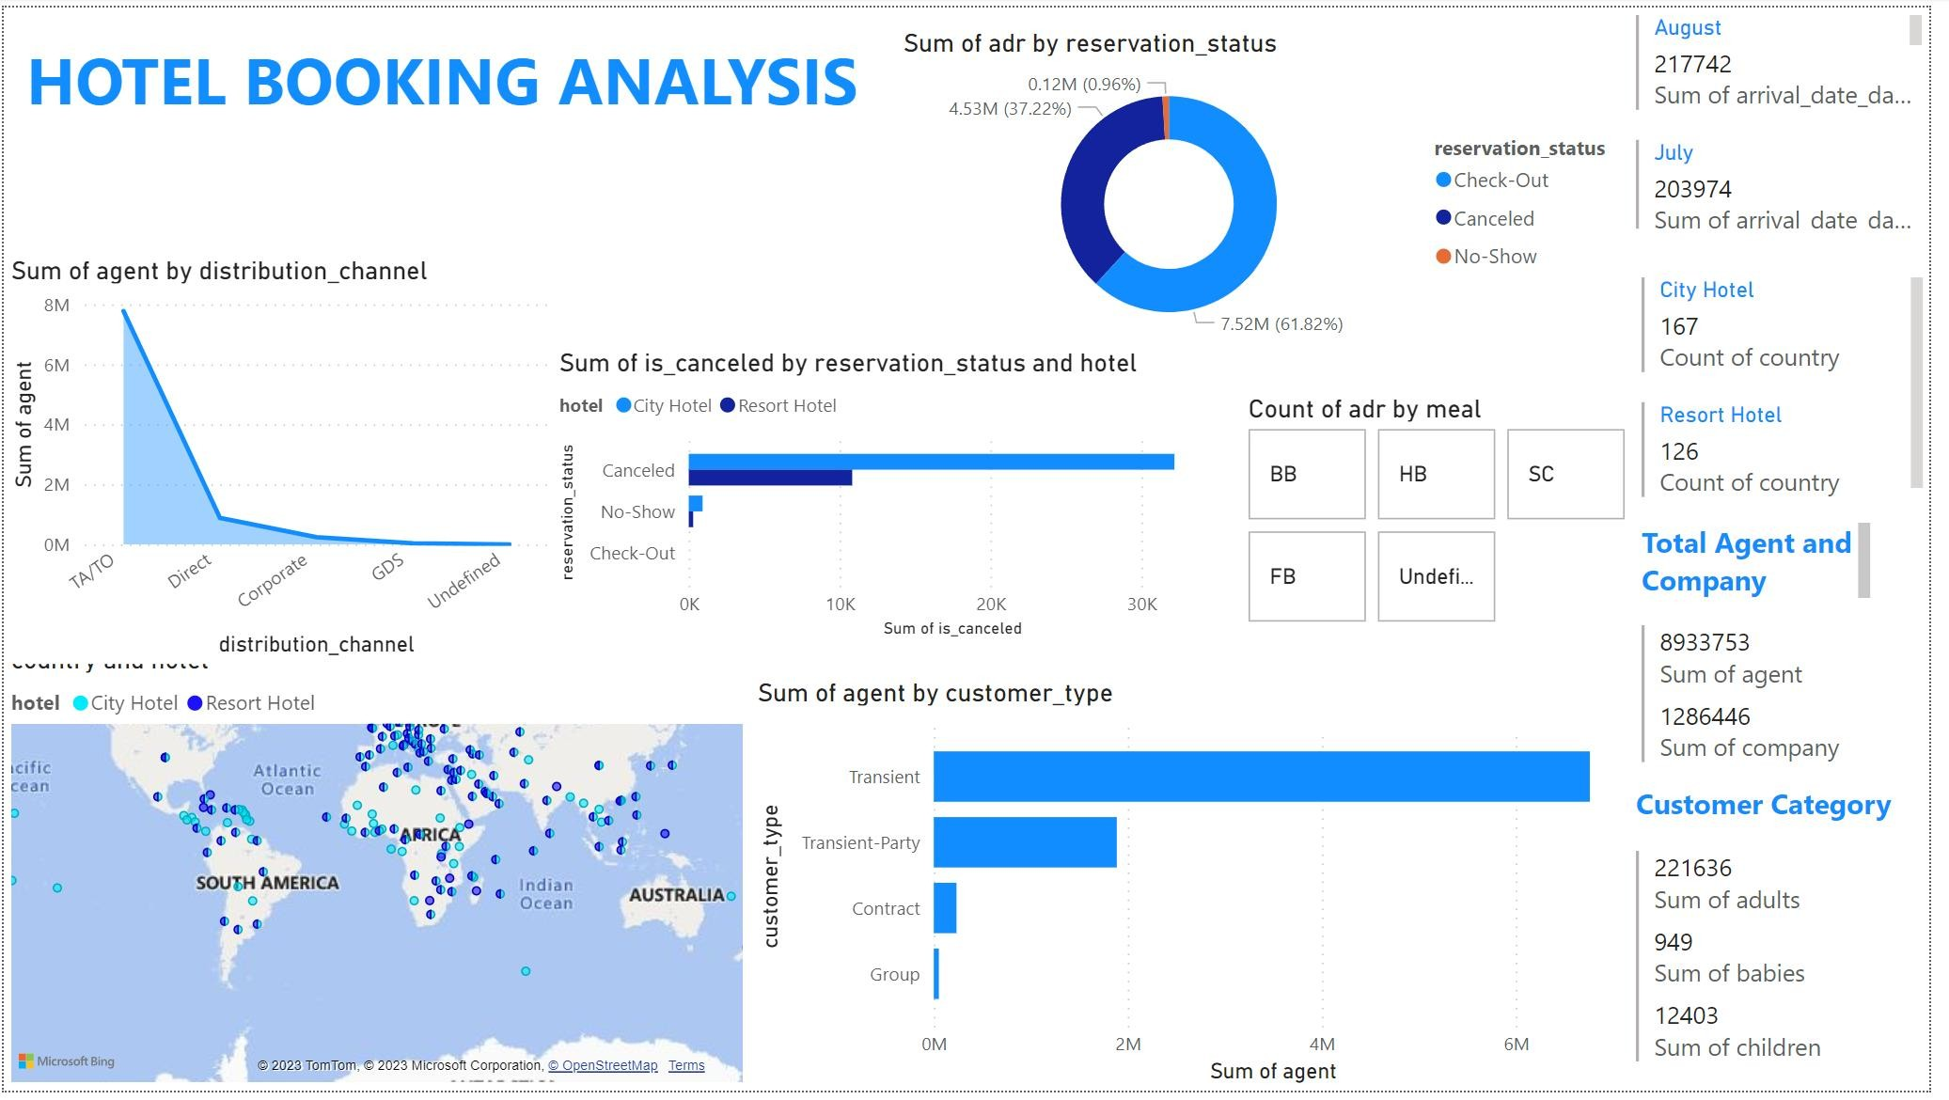

## How many agents are in different distribution channel?

### Gleaning the graph, the count of different agents across different distribution channel, where TA/TO has highest level of agent count.

9

## How many hotels across different country?

### Gleaning from the Country Report, it becomes apparent clear that there are two types of hotel, city hotel and resort hotel, which are speared across different country.

10

## How many agents across connect to different customers type?

### Gleaning from the customer type report there are maximum transient customers, and value of different customer is decreasing

11

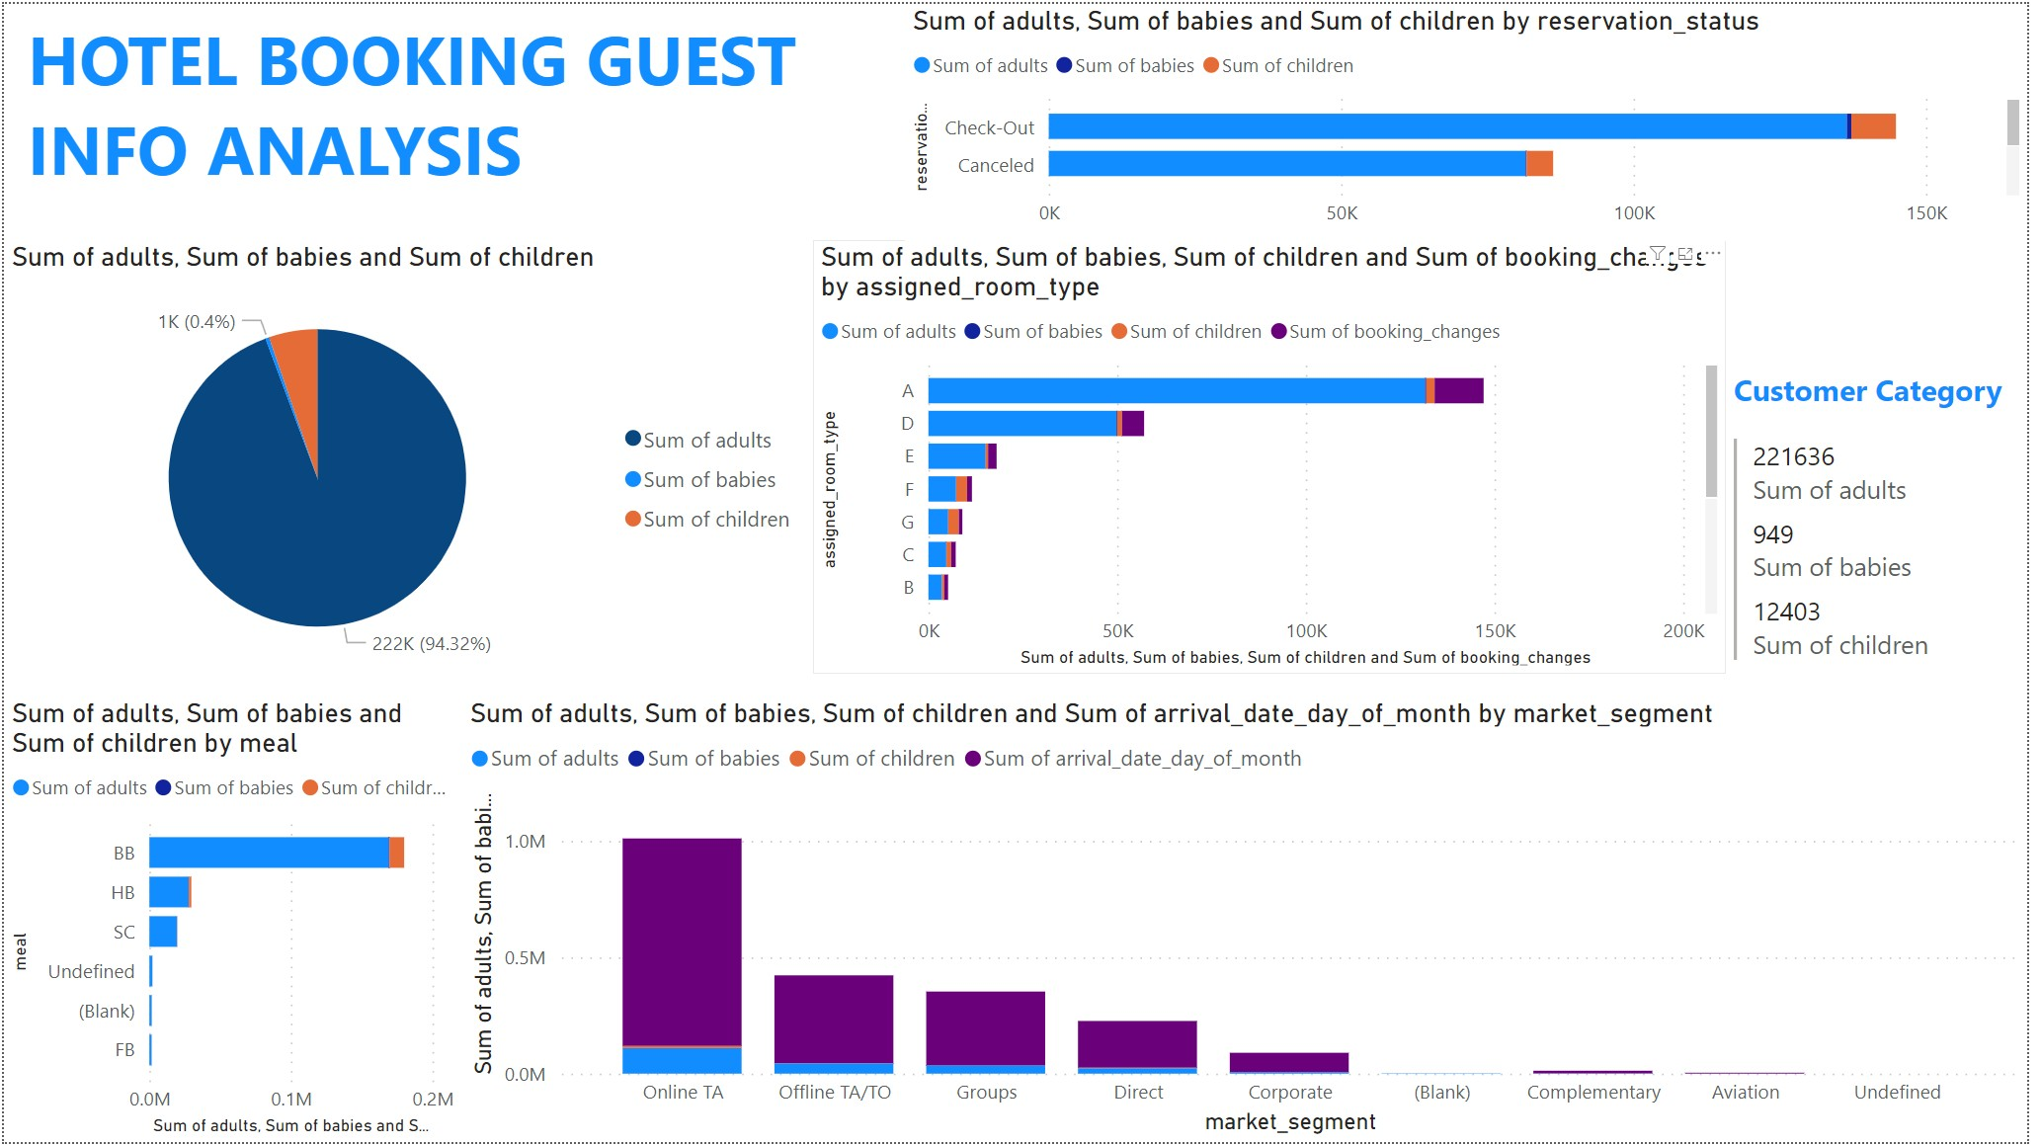

## How many adults, babies, children are in the reservation category?

### Gleaning from the graph maximum number of adults are check-out and canceled, while other are not shown.

13

## How many guest are category in different market segment ?

### Gleaning from the graph online TA has the highest guest ,while corporate has the lows level,

14

## what is the ratio of adult , babies , children?

### Gleaning from the Report there are 94% of adult and 0.4% of children and the rest of the is babies.

15

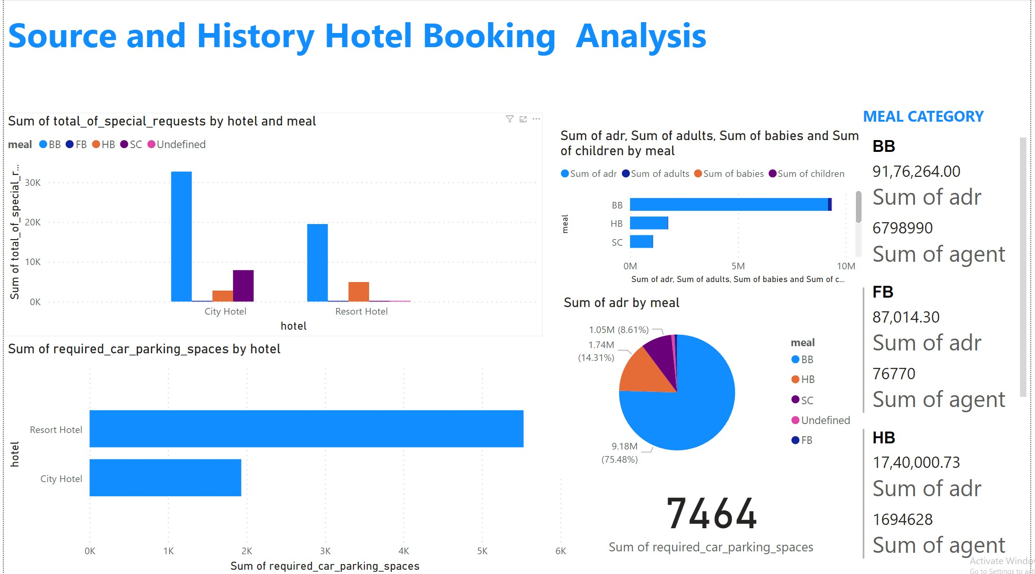

## What is the average daily rate with meals?

### Gleaning from the report 75% of adr serve bb meal and 14% hb meal and 9% Sc meal.

17

## what is different meal serve different guest type?

### City hotel and resort meal both receive bb meal maximum while resort receive FB ,HB , SC very less.

18

## What are the car parking request in different hotel?

### Gleaning from the report resort hotel receive maximum parking request.

19

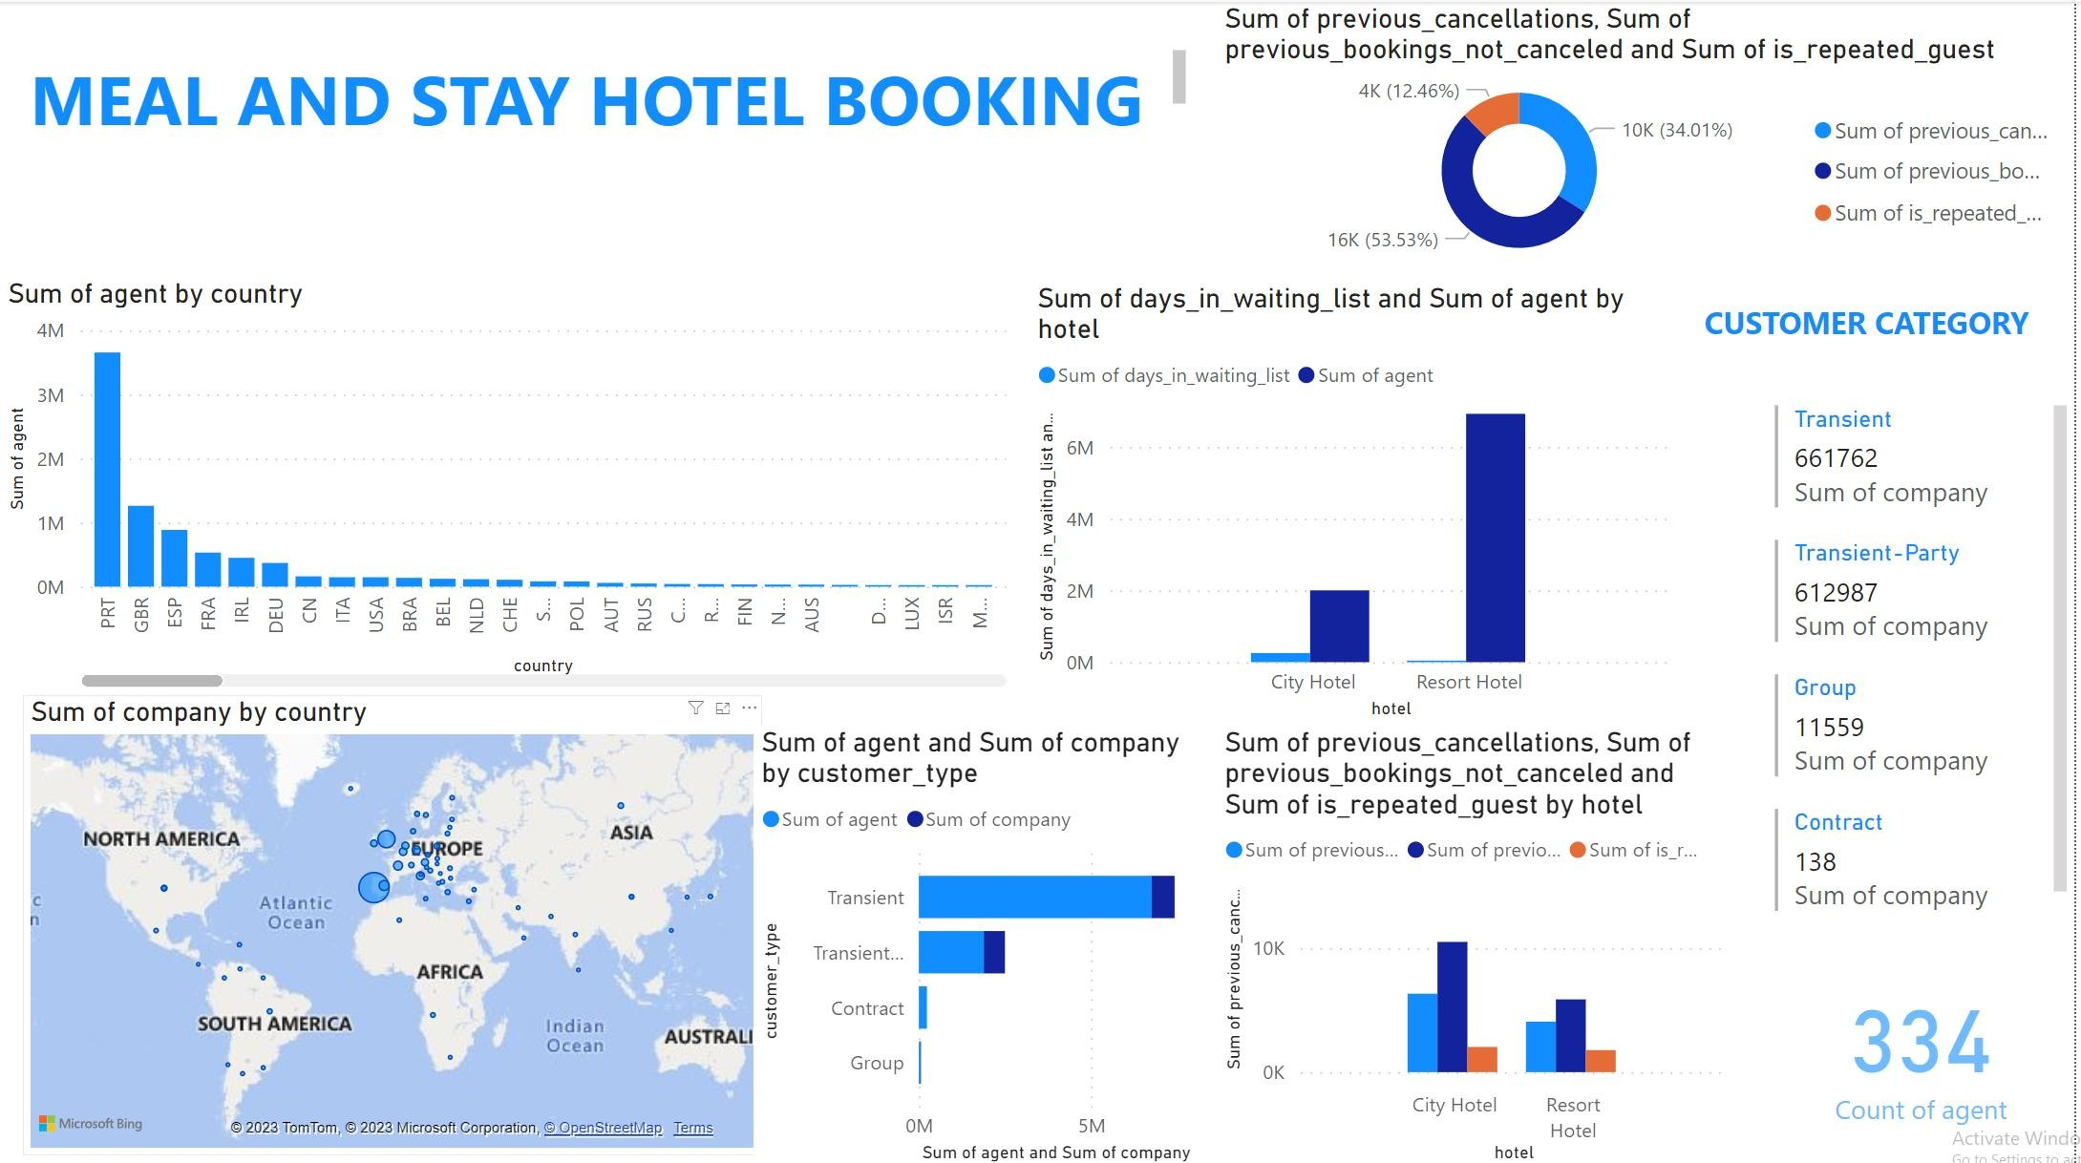

## what are number of agent in different country?

### Gleaning from the report most of agents are in PRT AREA.

21

## How many cancelation, repetition, previous boking not cancel?

### Gleaning from report most of hotel has previous booking not cancel.

22

## Numbers of agent in comparison with days in waiting list.

23

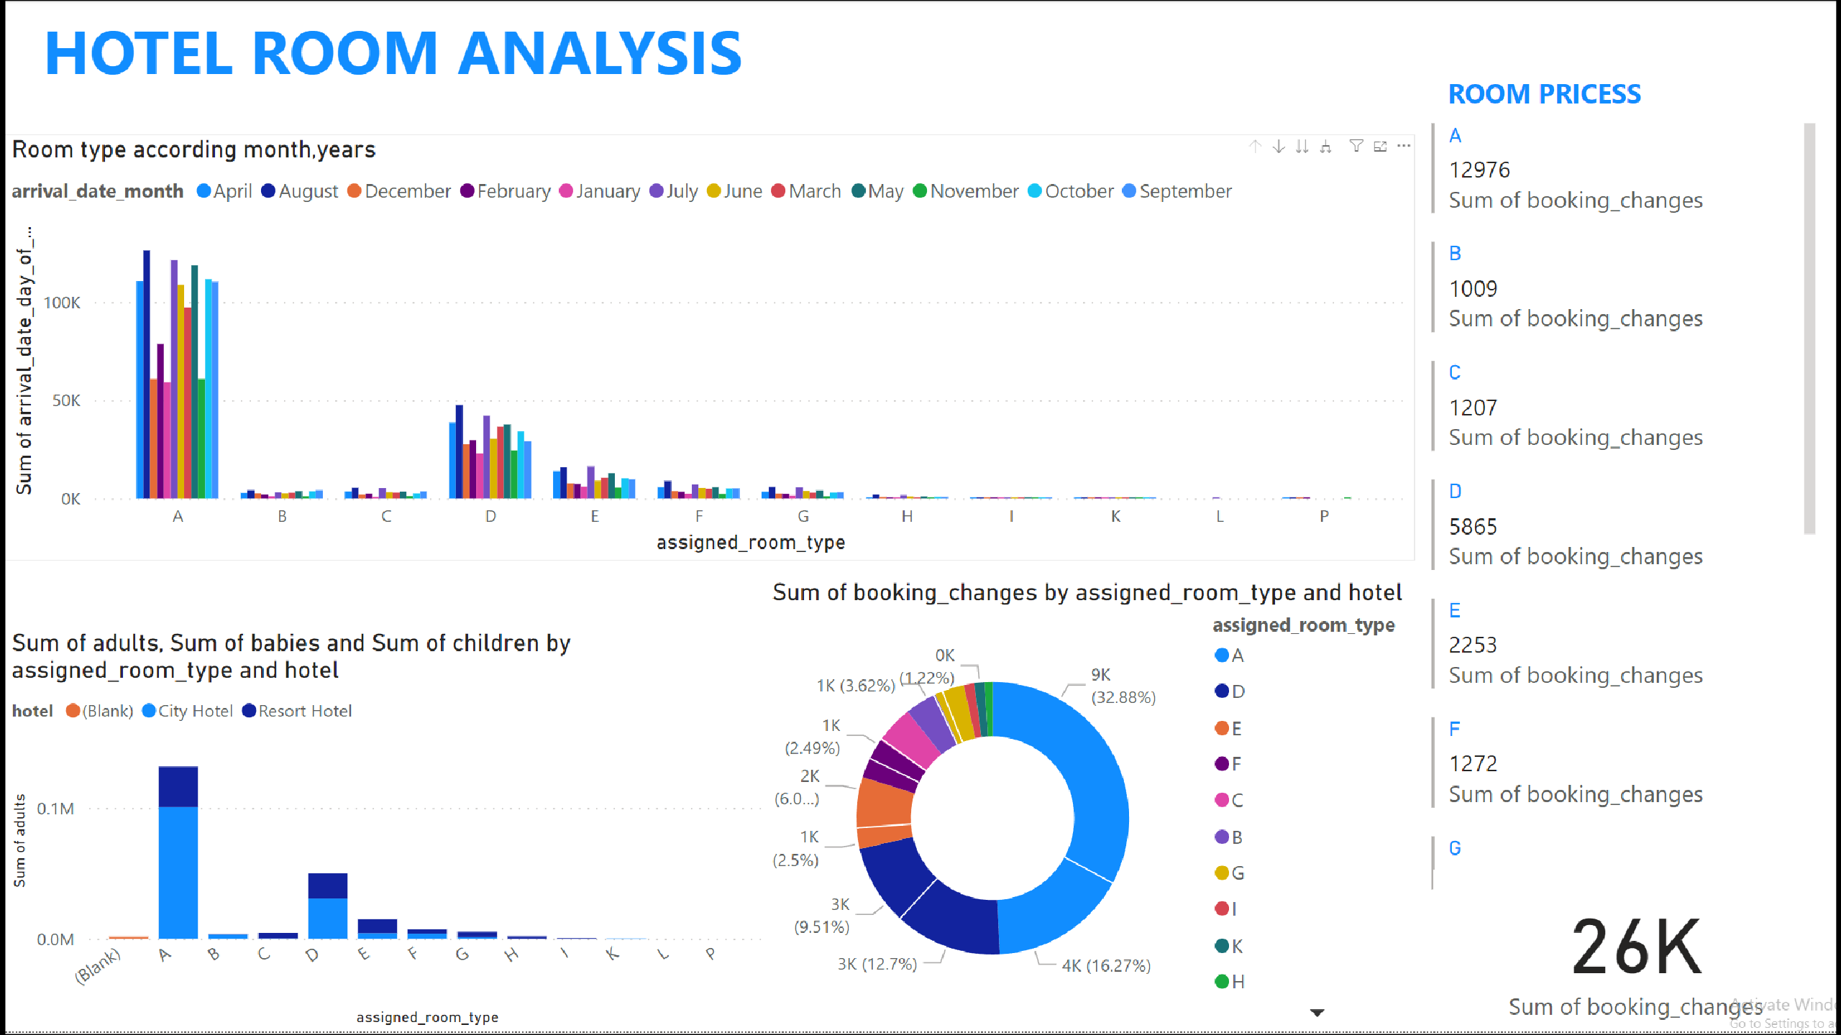

## These are assigned room type according to the arrival date of the months.

25

## These are the sum of booking changes by assigned room type and hotel type.

26

## The graph represents

the different guest type is staying in different room types and which hotel type has highest room reserved.

27

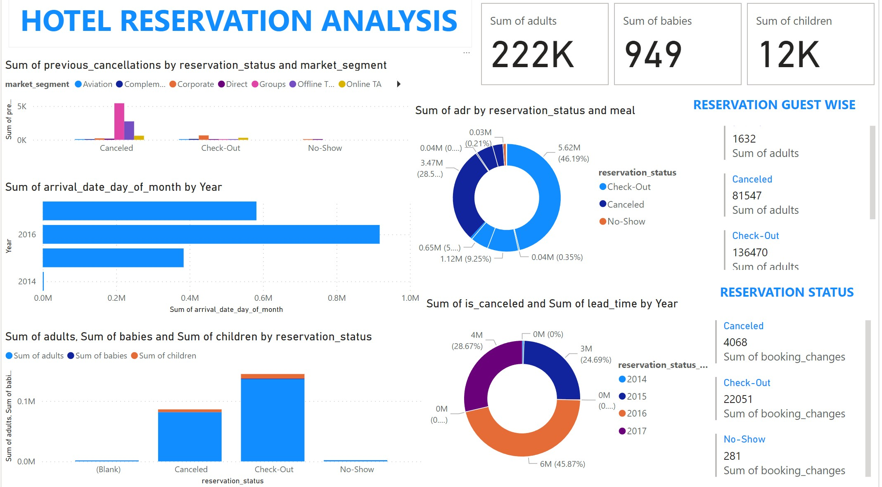

28

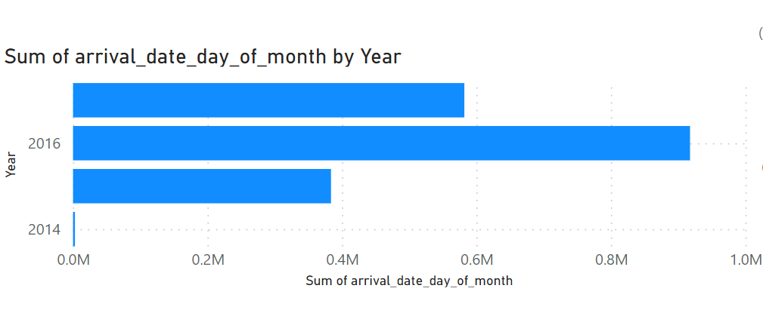The graph represents how many people have arrived on the date of the month on different years.

29

### The graph represents the sum of pervious cancellation by reservation status and market segment.

30

### The graph represents sum of average daily rate by reservation status and meal plan and also show

the total numbers adults, cancelation and check-out.

31

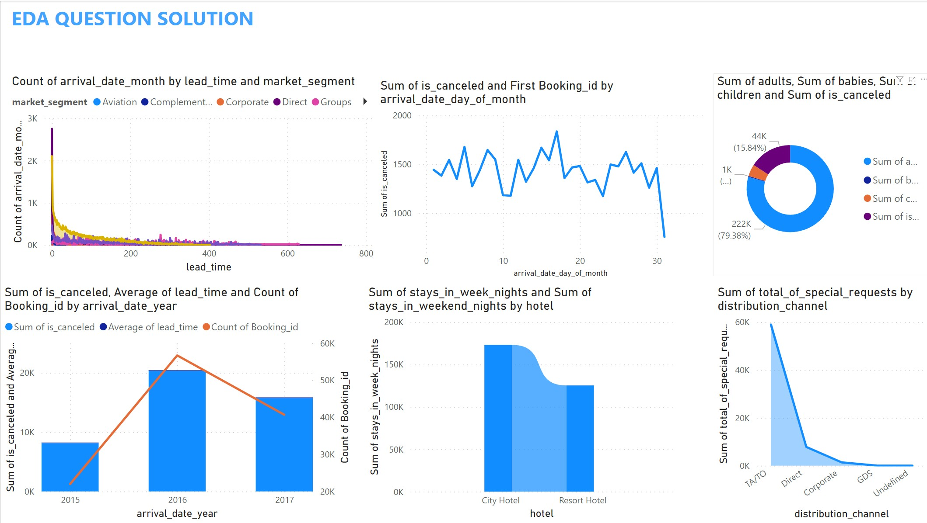

32

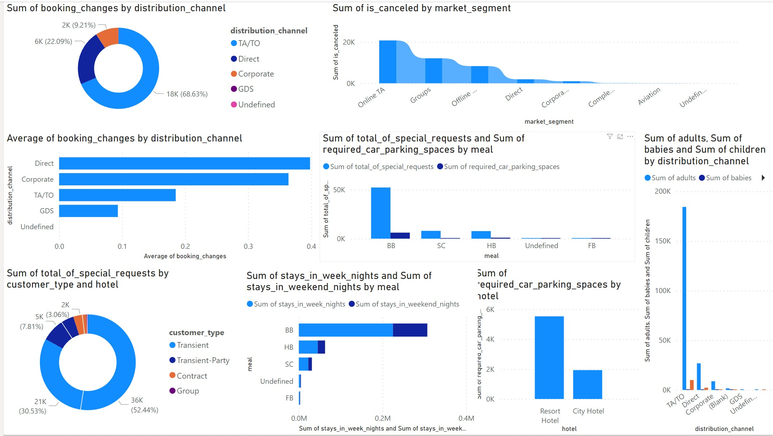

33

### SSS

34



EDA Problem Statements Excel & SQL

* EDA questions

Q1. These are the questions that you will need to answer after doing the required analysis. (Note: You may earn bonus marks by providing additional analysis.) Q2.Understand the distribution of arrival dates, including the most common arrival days and summary statistics for lead times.

Q3.Identify peak booking months and analyse reasons for spikes in bookings, including holidays or events. Q4.Calculate the average length of stays for different hotel types and explore variations by meal plans.

Q5.Analyse how booking patterns have evolved over the years, including year over year changes in bookings and cancellations. Q6.Understand the distribution of the number of adults, children, and babies and identify any outliers.

Q7.Calculate summary statistics for ADR and explore differences between Resort Hotel and City Hotel bookings.

Q8.Analyse the distribution of required car parking spaces for each hotel type and determine if one type attracts more guests with cars.

Q9.Compare the total number of special requests made by different customer types (e.g., Transient, Group) and identify which customer type makes more requests. Q10.Understand the distribution of meal plans (e.g., BB, HB, FB, SC) and identify any patterns or preferences.

Q11.Analyse Average Daily Rates (ADR) by meal plan type to identify variations in pricing.

Q12.Investigate the distribution of required car parking spaces and special requests by hotel type and meal plan. 12. Compare the distribution of meal plans among

* Q13.different customer types (e.g., Transient, Group) to identify preferences.

Q14.Understand the distribution of bookings across different market segments and calculate summary statistics for lead times within each segment.

Q15.Analyse the distribution of bookings through different booking channels (e.g., online travel agents, direct bookings) and calculate the percentage of bookings through each channel. Q16.Calculate the proportion of repeated guests and investigate their booking behaviour. Identify any patterns or differences in preferences compared to first-time guests.

Q17.Explore the impact of a guest's booking history on their likelihood of cancelling a current booking. Calculate cancellation rates based on previous cancellations and noncancelled bookings. Q18.Understand the distribution of reserved and assigned room types. Calculate summary statistics for the consistency between reserved and assigned room types.

Q19.Analyse the impact of booking changes on cancellation rates. Calculate cancellation rates for bookings with different numbers of changes.

Q20.Explore how room type preferences vary across different customer types (e.g., Transient, Group). Identify if certain customer types have specific room preferences. Q21.Examine whether guests who make multiple bookings have consistent room type preferences or if their preferences change over time.

Q22.Understand the distribution of reservation statuses and calculate summary statistics for reservation status dates. Q23.Analyse trends in reservation status dates, including the most common checkout dates and any seasonality patterns.

Q24.Explore how reservation statuses vary across different customer types (e.g., Transient, Group) using Excel or SQL. Calculate cancellation rates by customer type. Q25.Investigate whether there are differences in Average Daily Rates (ADR) based on reservation status (e.g., canceled vs. checked out).

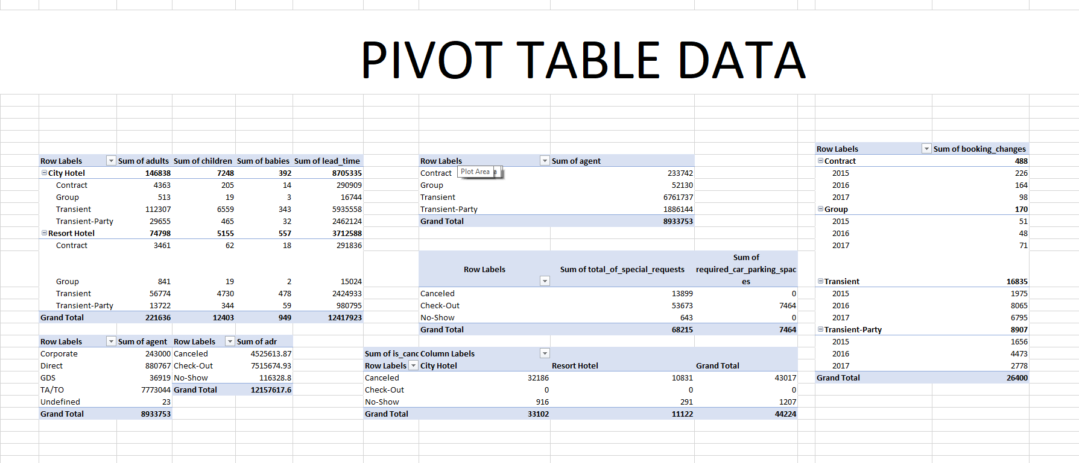

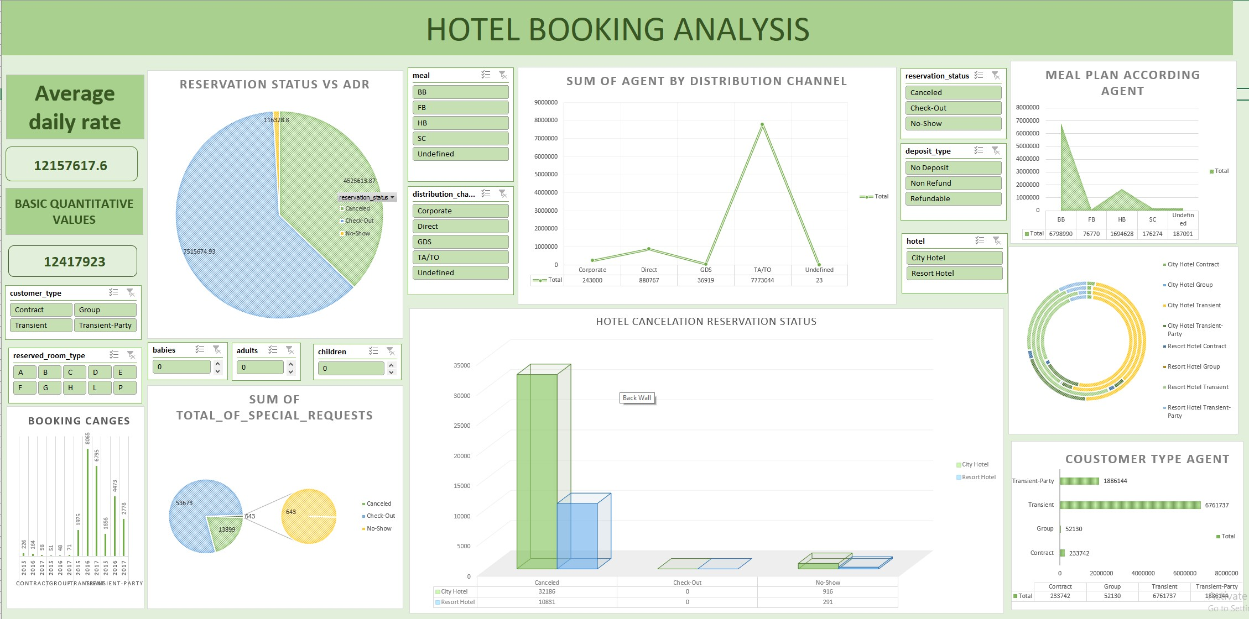

SQL ANALYSIS

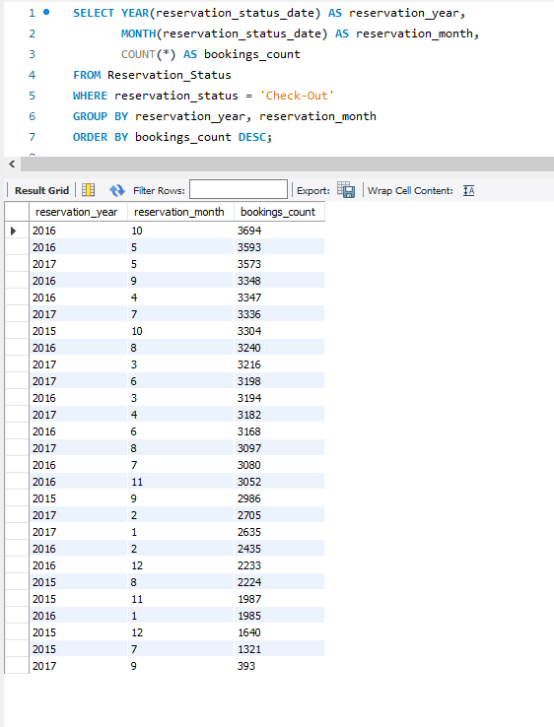

### 1. Distribution of Arrival Dates: 2. Peak Booking Months and Analysis:

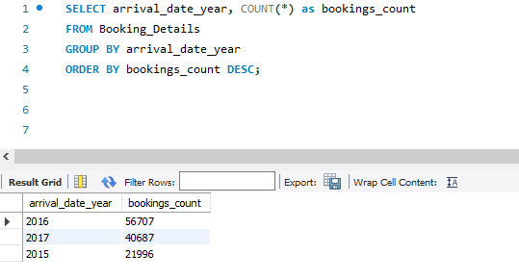

SQL ANALYSIS

### 3. Average Length of Stays for . Booking Patterns Evolution Over Years Different Hotel Types

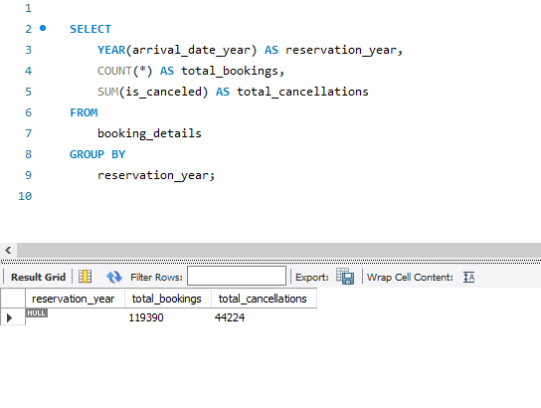and Meal Plans:

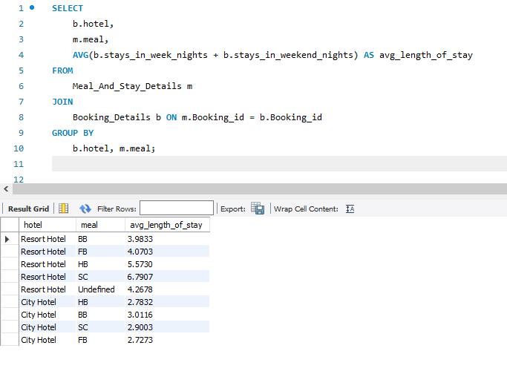

SQL ANALYSIS

### 5. Distribution of Adults, 6. Summary Statistics for ADR by Children, And Babies: Hotel Type:

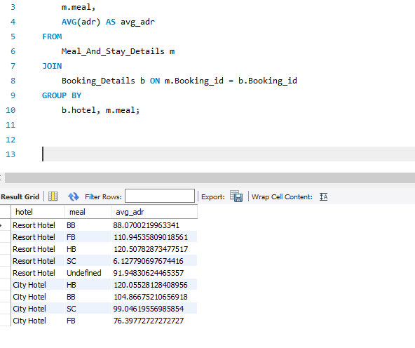

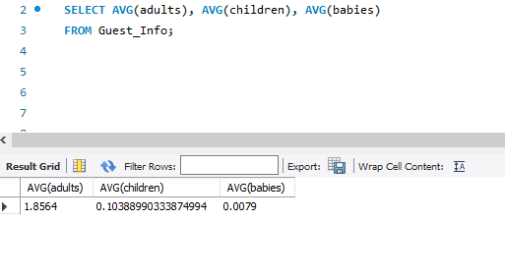

SQL ANALYSIS

### 7. Distribution of Required Car 8. Total Special Requests Parking Spaces by Hotel Type: by Customer Types:

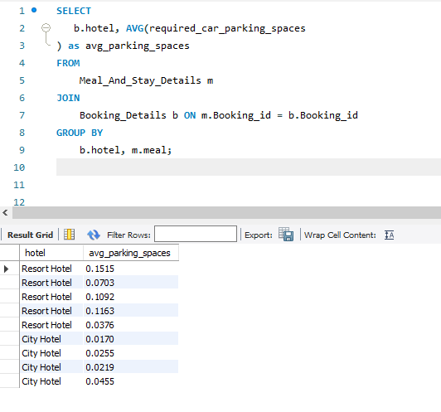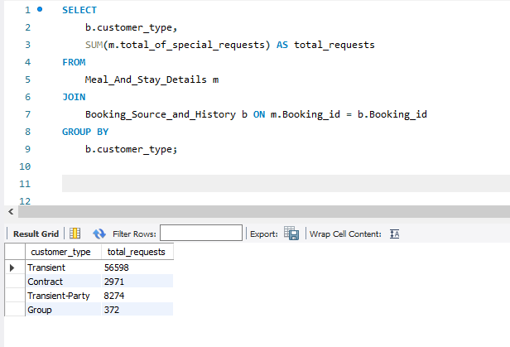

SQL ANALYSIS

### 9. Distribution of Meal Plans: 10. ADR by Meal Plan Type:

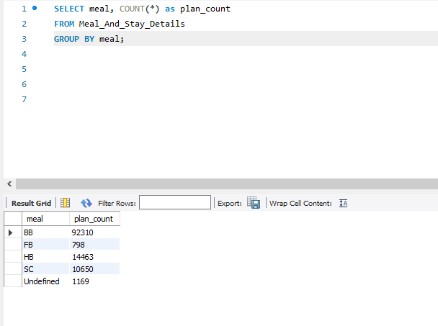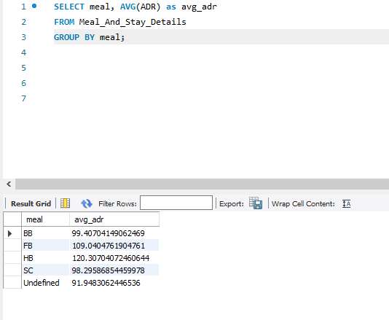

SQL ANALYSIS

### 11.Distribution of Parking Spaces and 12. Comparison of Meal Plans Among Special Requests by Hotel type different customer type,

Meal plan.

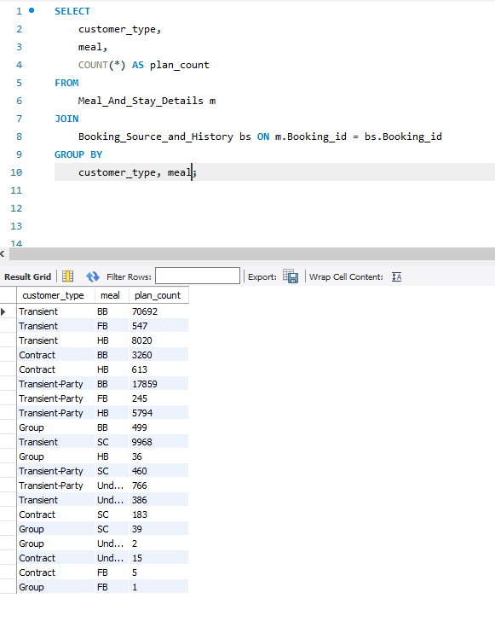

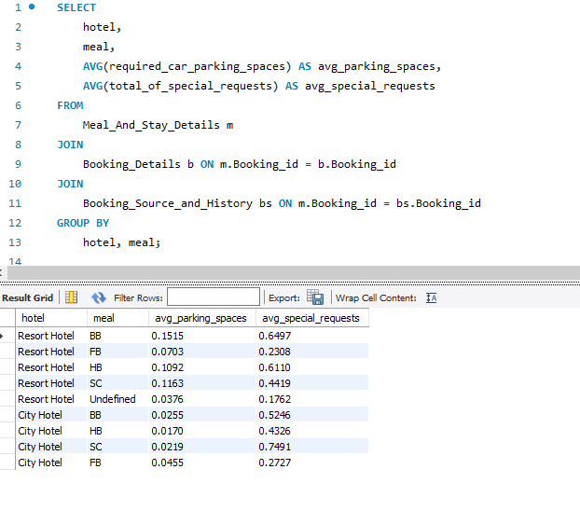

SQL ANALYSIS

### 13. Distribution of Bookings 14. Distribution of Bookings

Across Market Segments: Through Different Channels:

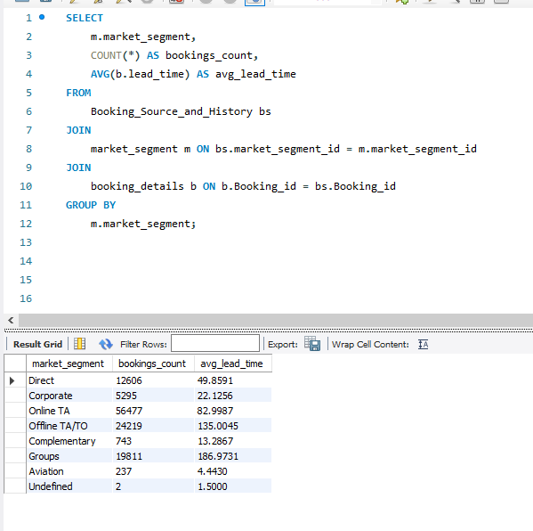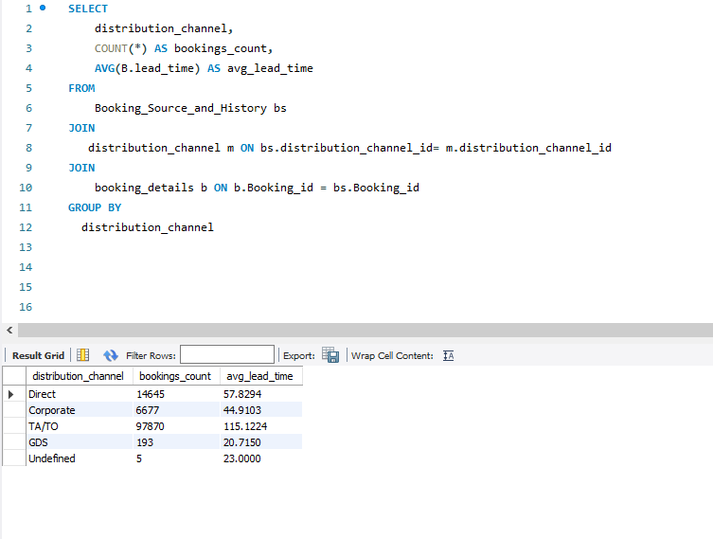

SQL ANALYSIS

### 15. Proportion of Repeated 16.Impact of Guest's Booking History on Guests and Their Booking Behavior: Cancellation Likelihood:

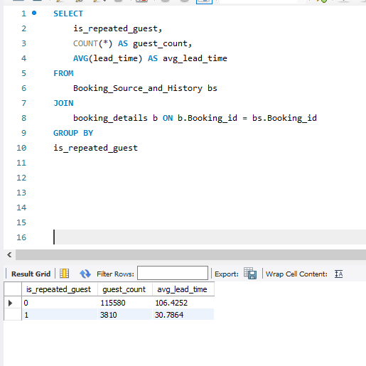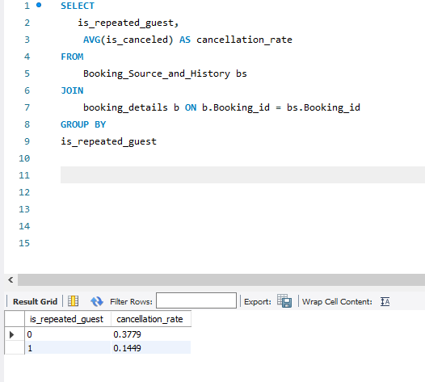

SQL ANALYSIS

### 17.Distribution of Reserved 18.Impact of Booking Changes on and Assigned Room Types: cancellation rate

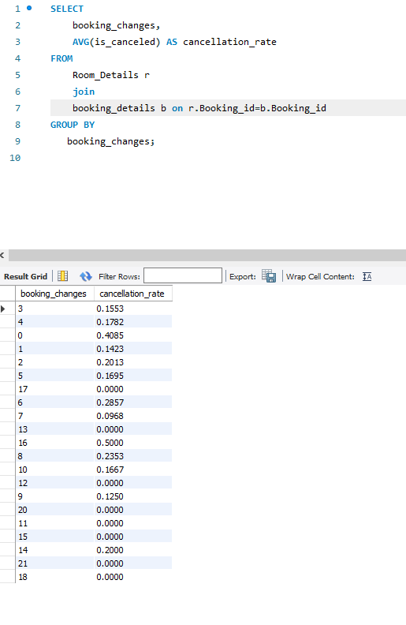

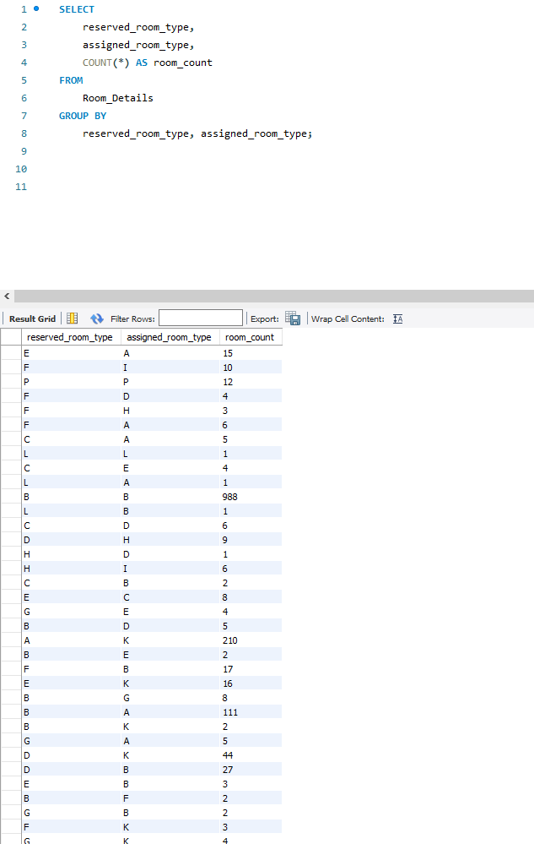

SQL ANALYSIS

### 19.Variation of Room Type Preferences 20.Consistency of Room Type Across Customer Types: Preferences for Guests Making

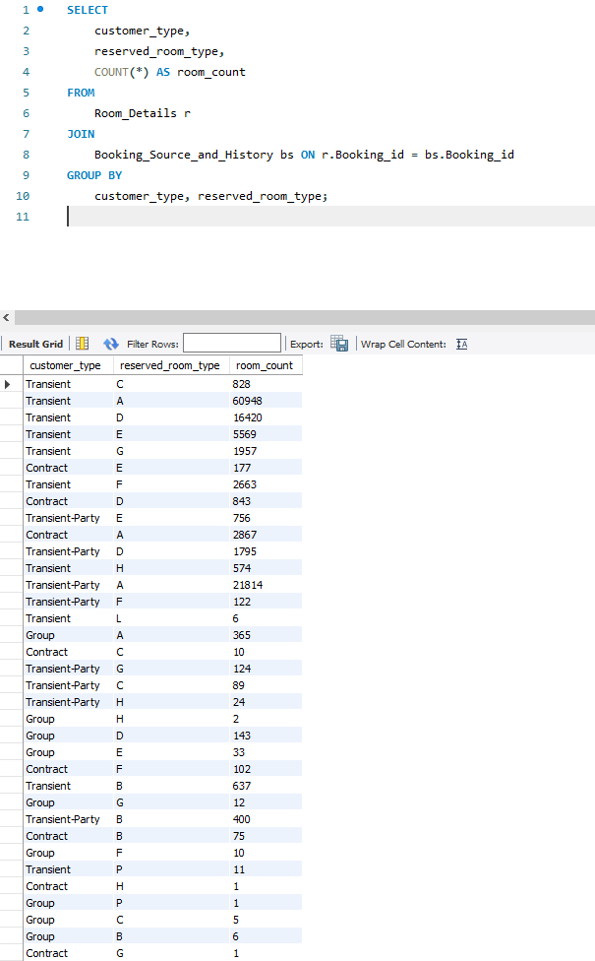Multiple Bookings:

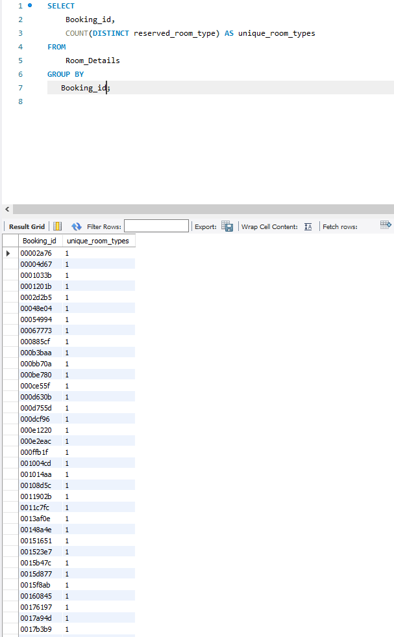

SQL ANALYSIS

### 21.Distribution of Reservation 22. Analysis of Trends in Statuses: Reservation Status Dates:

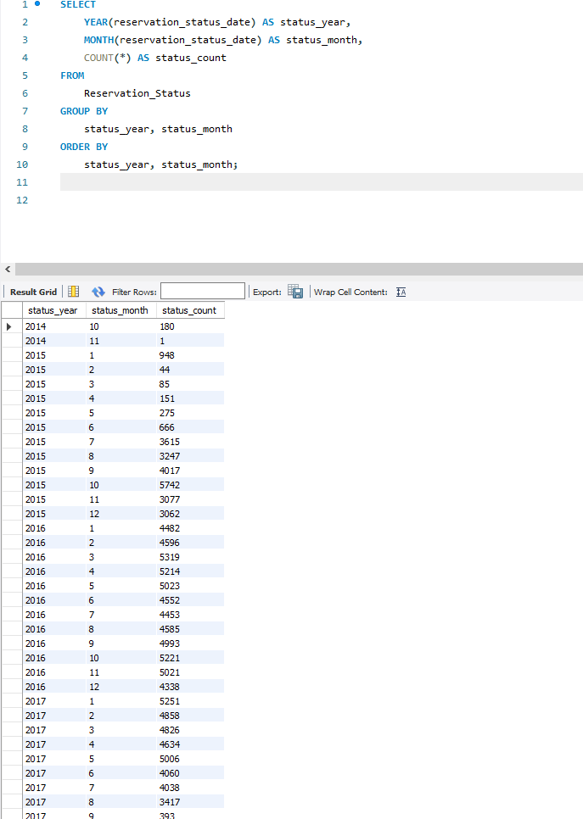

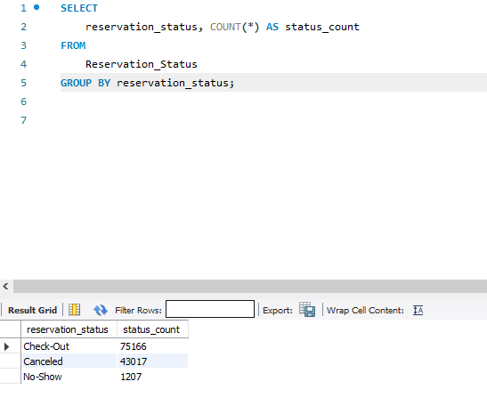

SQL ANALYSIS

### 23.Variation of Reservation 24.Differences in ADR Based on Statuses Across Customer Type Reservation Status:

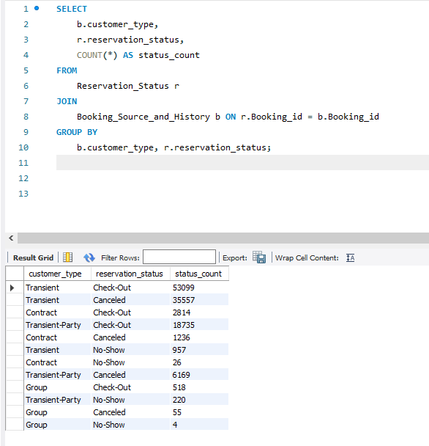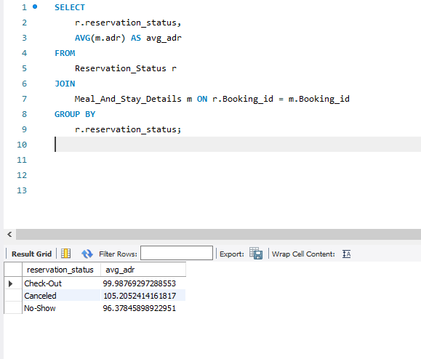

THANKYOU